**RECRUITMENT SYSTEM**

**AIM**:

To design on a mini project on recruitment system and to draw all UML diagram using Argo UML modelling tool.

**PROBLEM STATEMENT**:

The recruitment system allows the job seekers to enroll their names through the process of registration. The employee also can get the list of available candidates and shortlist for their company requirement. One applicant enrols he receives an id, which helps him in further Correspondence. A fees amount is received from the seekers for enrollment. This system makes the task of the job seeker easier rather than waiting in queue for enrolment. This also reduces the time consumption for both for the job seeker and employee.

**I. USE CASE DIAGRAM:**

The use case diagram consists of various functionality performed by the actors like HR Head, Employee and candidate recruiter database. The use case diagram consists of various functionally like notify vacancy, fill refer form, selection of eligible candidate, interview process, information to selected candidate, accept define after, award bonus.

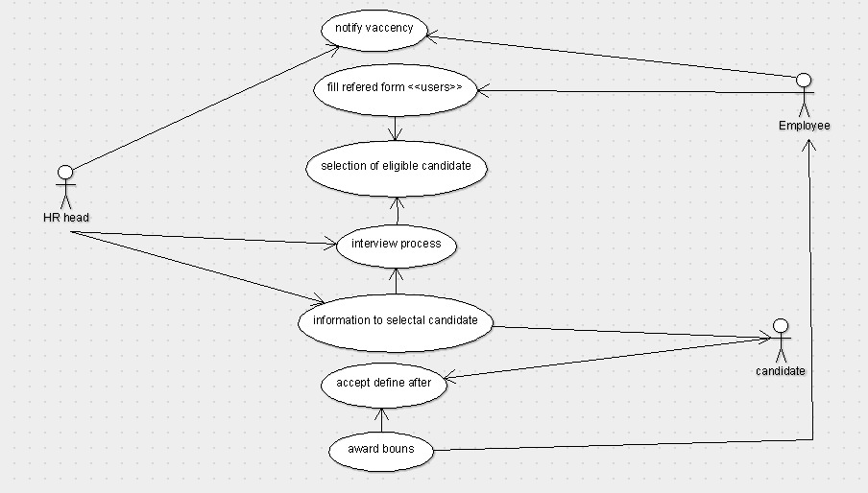

**II. ACTIVITY DIAGRAM**

Here in the activity diagram the applicant login to the register and status. The HR login to the applicant details and authentication in the database. The final interactions send response and delete application of the applicant.

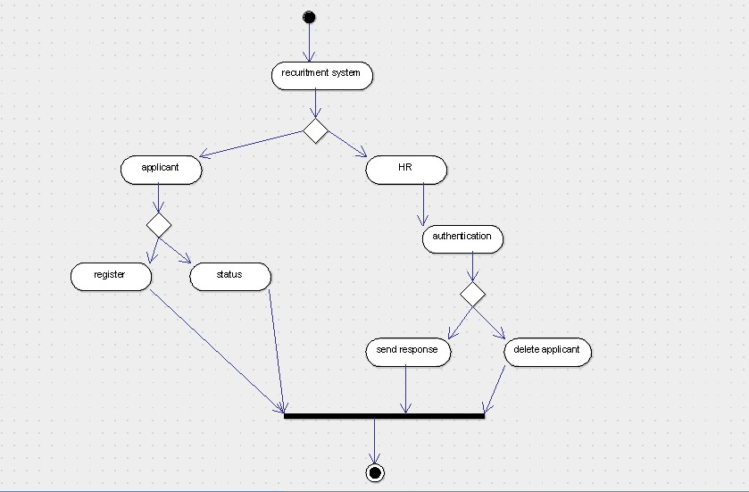

**III. UML CLASS DIAGRAM**

The recruitment system makes use of the following classes like recruitment system, register class, status class and admin panel.

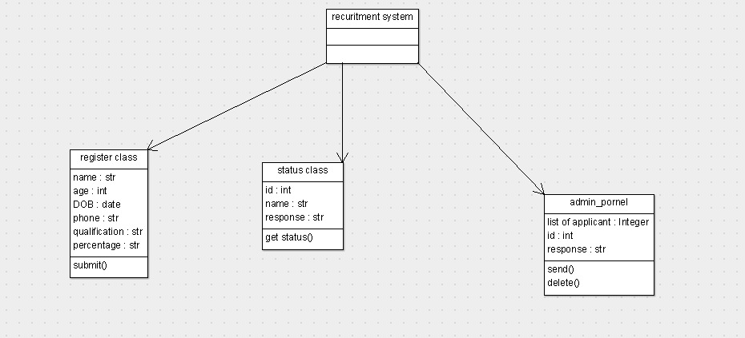

**IV. UML SEQUENCE DIAGRAMS**

A sequence starts the between the aplicant and the register. The second half takes place between applicant and status. The takes place between HR and admin panel. The applicant register to the system and store the detials in data base.HR login to the system verify the detials of the applicant database.the response has to be send to the applicant.

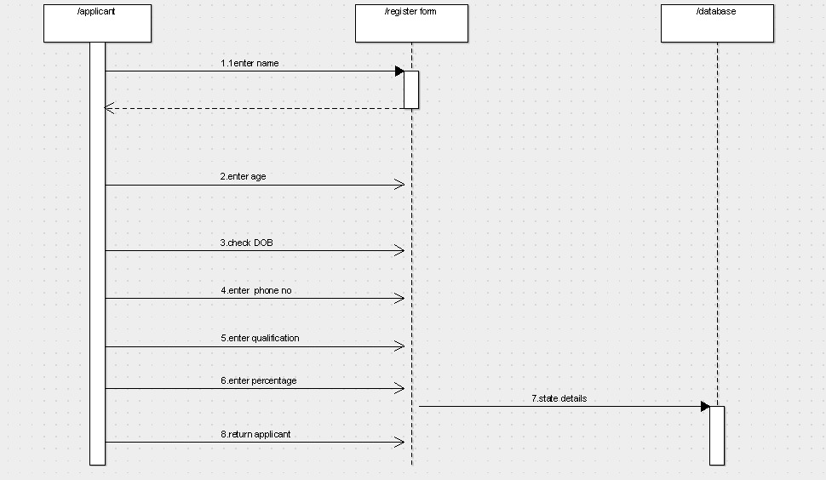

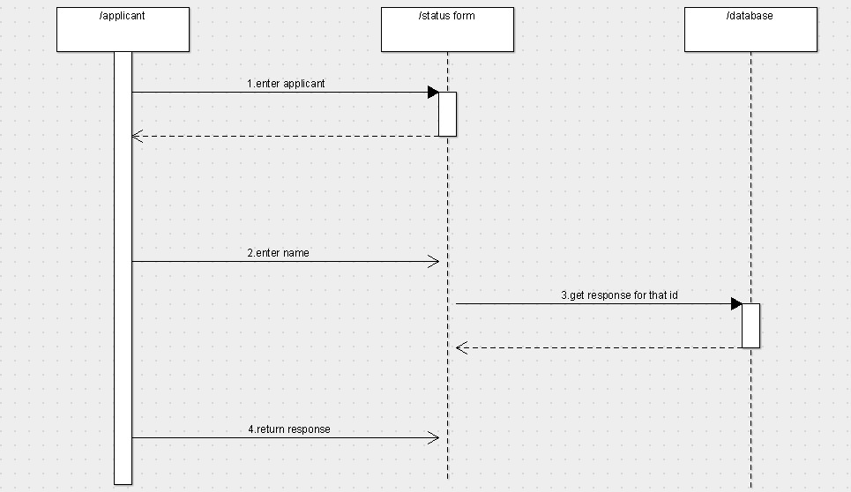

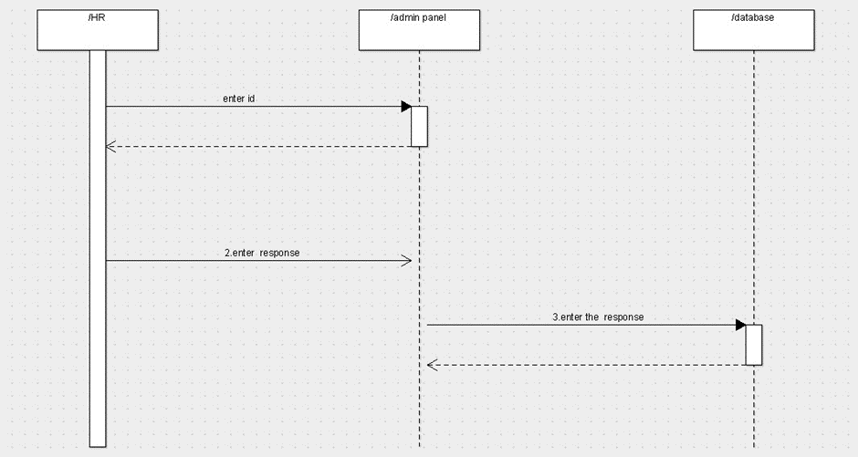

**V. UML COLLABORATION DIAGRAM**

This collaboration diagram is to show how the applicant login and register in the recruitment system. Here the sequence is numbered according to the flow of execution. The selection process applicant for the job. The flow of execution of this selection process is represented using the number.

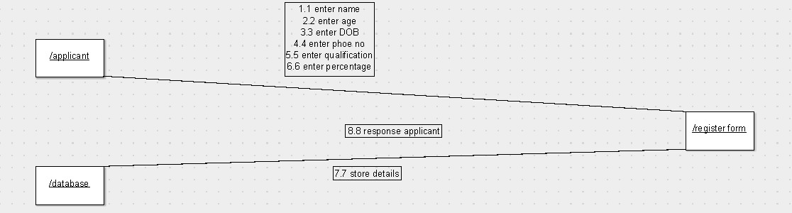

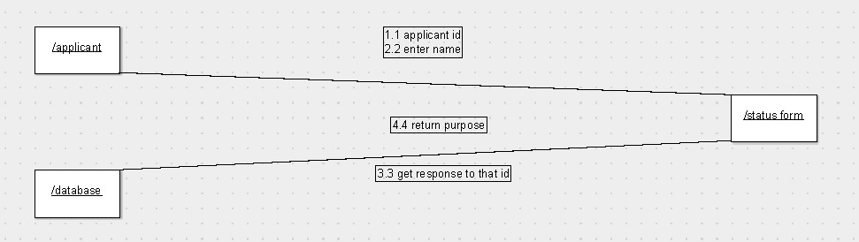

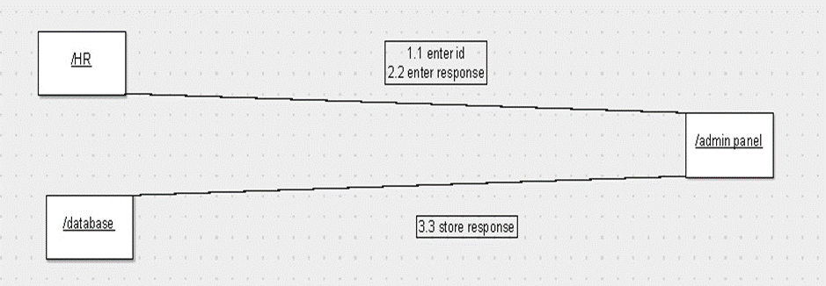

**VI. PARTIAL LAYRED LOGICAL ARCHITECTURE DIAGRAM** The user interface layer consists of the web and login. This layer describes how the applicant logins to the website and apply for the job. the domain layer shows the activities that are perform in the online recruitment system. The Technical services layer the applicant details, verification details and the selected applicant details are store in the database.

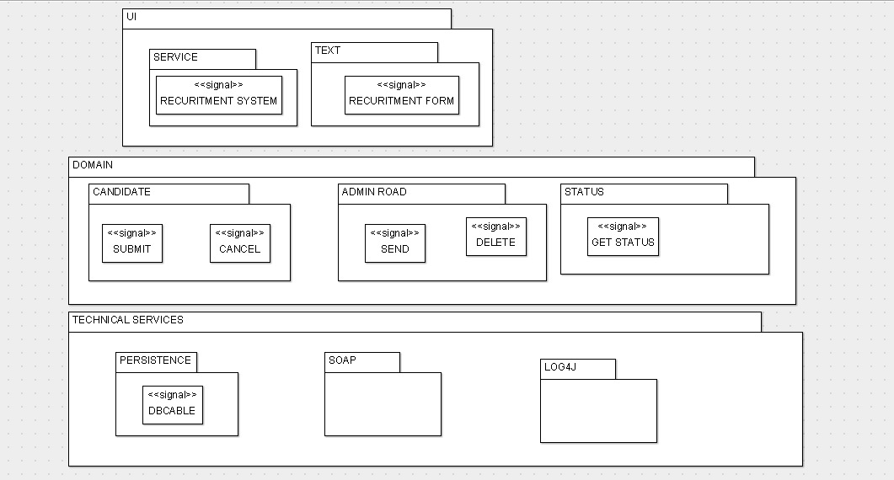

**VII.DEPLOYMENT DIAGRAM**

The processor in this deployment diagram is online recruitment system which is the main part and the devices are the register, appear for test and select talented applicant which are the some of the main activities performed in the system.

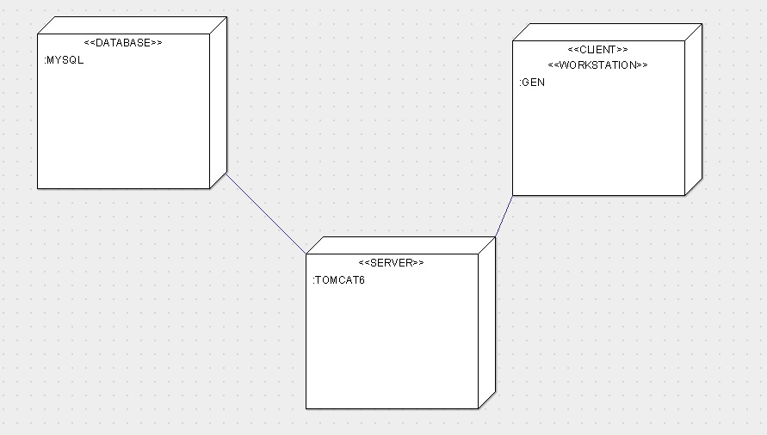

**VIII. COMPONENT DIAGRAM**

The main component in this component diagram is online recruitment systems. And register, attend test and select talented applicants are the components comes under the main component.

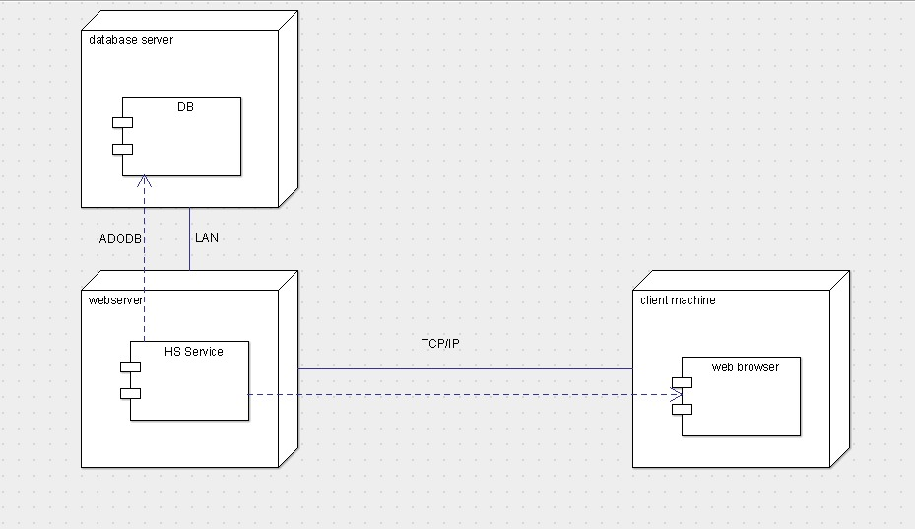

**PROGRAM**

**RECRUITMENT SYSTEM**

Public class Recruitment system extends Register class, Status class, Admin panel {

}

**REGISTER CLASS**

Public class Register class {

Public string Name;

Public integer Date;

Public Date DOB;

Public integer phone no;

Public string authentication;

Public string percentage;

Public void Submit () {}

}

**STATUS CLASS**

Public class status class {

Public integer id;

Public string name;

Public string response;

Public void get status () {}

}

**ADMIN PANEL**

Public class Admin panel {

Public DataGrid List of Applicants;

Public integer id;

Public string response;

Public void Send () {}

Public void Delete () {}

}

**RESULT:**

This the mini project for recruitment system has been successfully executed and codes are generated.